The AI Document Template & Content Management system is a comprehensive solution for creating professional content across 15+ languages with categorized templates for blogs, websites, social media, emails, and videos. The platform offers advanced customization options including creativity levels, tone selection, and character length specifications, generating up to 5 content variations with professional Word export capabilities. With detailed history tracking, word usage analytics, and comprehensive search functionality, users can efficiently manage their content library while maintaining quality across global markets with proper cultural context and keyword optimization.
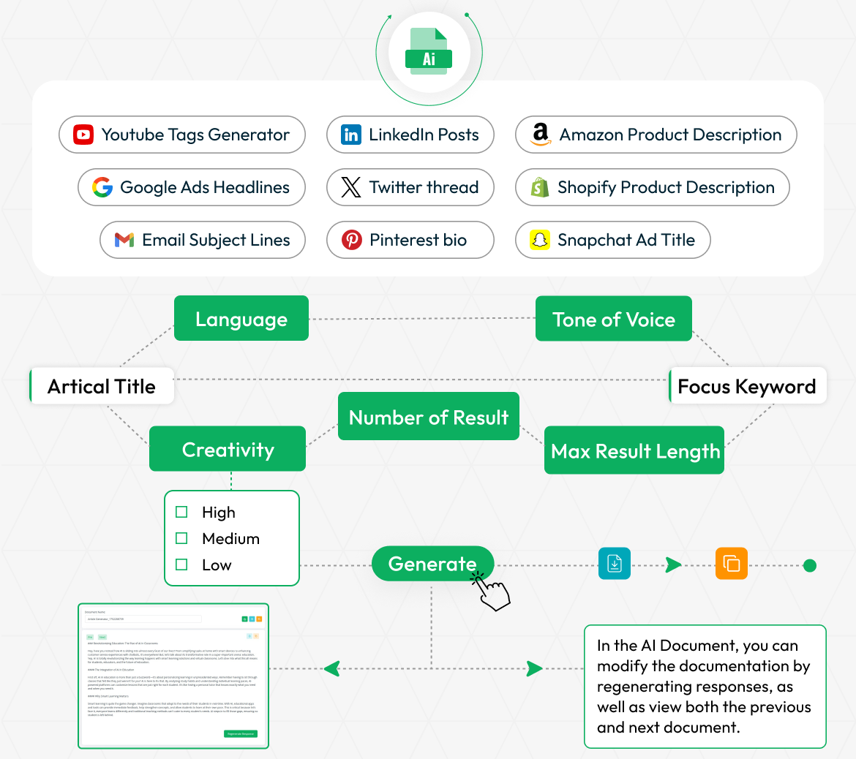

AI-Powered Content Generation Workflow
This layout presents a streamlined process for generating various types of written content using AI. It supports outputs such as product descriptions, ad headlines, social media posts, bios, and email subject lines. Users can define parameters like language, tone of voice, article title, focus keyword, creativity level, number of results, and maximum result length. Once configured, the system generates content tailored to the selected criteria, allowing for easy review, modification, and regeneration to suit diverse marketing and communication needs.

STRONG BRAND
Template & Content Management
Our template management system streamlines content creation with categorized templates like Content, Blog, Website, Social Media, Email, Video, and more. Templates are displayed in an intuitive card-based layout for quick selection. Generate professional content in 15+ languages including Arabic, Chinese, English, French, German, Japanese, and Spanish with cultural accuracy. Users can define focus keywords and article titles for targeted output.
- Categorized template organization with card-based selection
- Support for 15+ languages with cultural context
- Keyword optimization across multiple languages
- Global content localization

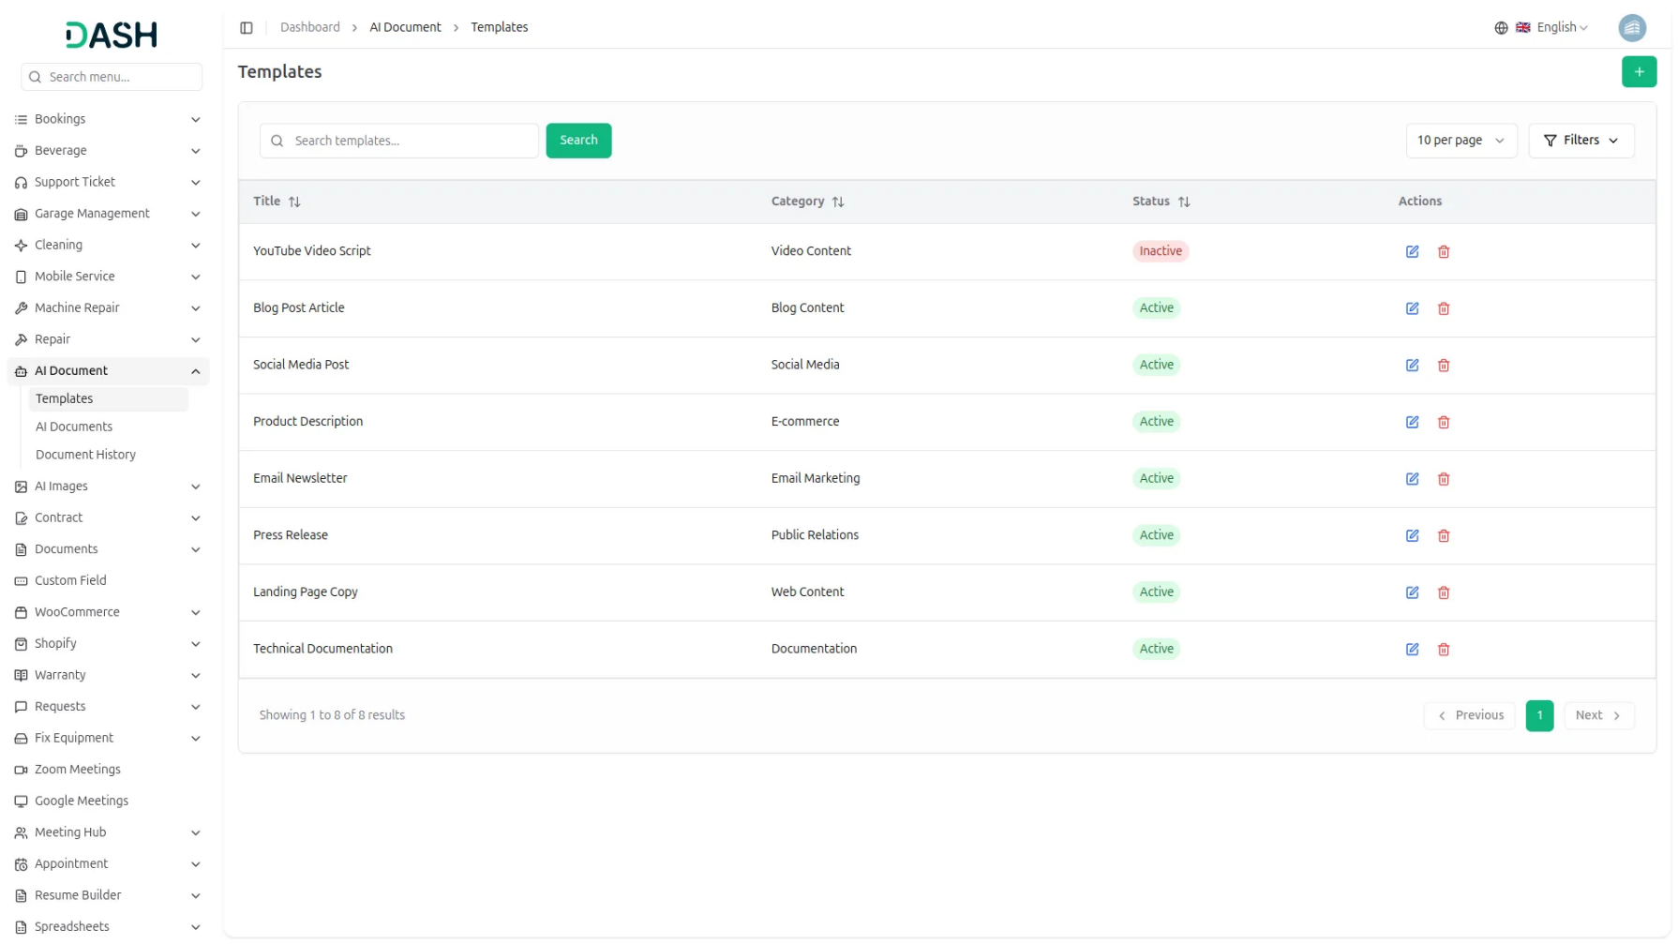

History & Analytics Tracking
Monitor content generation activities through detailed history tracking that records document names, categories, languages, word usage analytics, and creation dates with comprehensive search capabilities. Track word usage patterns to understand content generation trends while maintaining complete control over your document archive. The system provides edit and delete functionality for efficient content library management and easy retrieval of previously generated content.
- Comprehensive document history with search and analytics
- Word usage tracking and pattern analysis
- Complete document archive management tools
- Content retrieval and template reuse capabilities

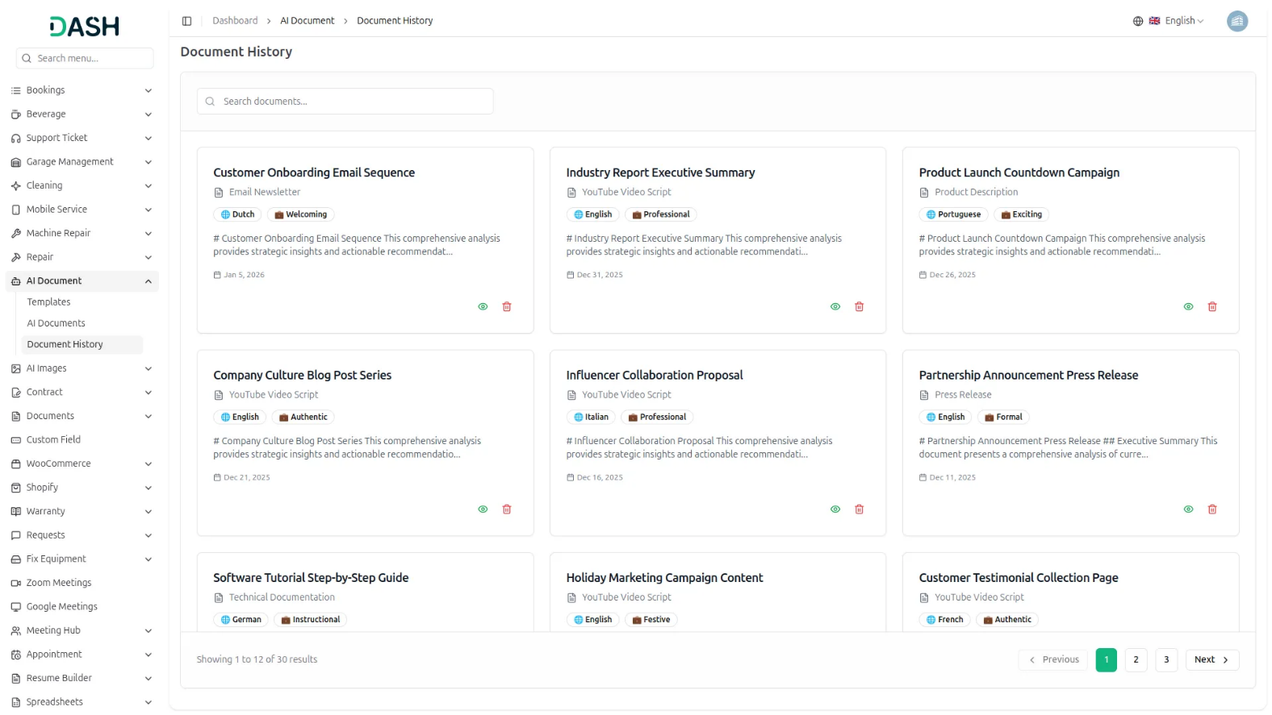

Introduction
The AI Document System is a comprehensive AI-powered content generation platform designed to help users create professional documents across various categories and languages. This system allows you to generate high-quality content using advanced AI technology with customizable templates, multiple language support, and various tone options. The platform includes template management, document generation, content customization, and history tracking features. Users can create content for blogs, websites, social media, emails, videos, and other purposes while maintaining complete control over language, creativity, and tone settings.

How To Use The AI Document Add-On?
Settings Configuration
- The Settings Configuration allows company administrators to set up the AI system with multiple AI provider integrations for content generation. This module must be configured before users can generate documents.
- To configure AI Document Settings, access the Settings Configuration section from the settings panel. Select your preferred AI Provider from the dropdown options including OpenAI, Anthropic Claude, and Google Gemini based on your requirements and subscription.
- Choose the appropriate AI Model from the dropdown which dynamically updates based on your selected provider. OpenAI offers models like GPT-4, GPT-4-Turbo, and GPT-3.5-Turbo. Claude provides claude-sonnet-4-5, claude-opus-4-1, and claude-3-5-haiku-latest options. Gemini includes gemini-2.5-flash, gemini-2.5-pro, and gemini-2.5-flash-lite models.
- Enter your API Key in the secure password field with show/hide toggle functionality for enhanced security. Save the configuration to enable AI document generation functionality for all users in the system.

Document Template
- To add a new Template, click the “Create” button, enter the Title, add a Category, and select the Status from the dropdown (Active or Inactive). Enter a Description for the template, then add the Prompt Template using placeholders like {title}, {keywords}, {tone}, {language}.
- The list page displays all templates in a table format with columns including Title, Category, Status, and Actions. You can use the search bar to find specific templates by name.
- Apply filters by selecting options from Filter by category and Filter by Status, then click “Apply” to activate the filters or “Clear” to reset them. Available actions include Edit to update template information and Delete to remove a template.

Document Generate Page
- The Document Generate Page is the main content creation interface where users customize their AI-generated content. This works with templates selected from the Document Template module and provides a comprehensive two-panel layout.
- On the left side of the page, start by selecting your preferred Template from the available options. Enter your document Title in the designated field which is required for generation.
- Select your preferred Language from the comprehensive dropdown menu including English, Arabic, Chinese, Danish, Dutch, French, German, Hebrew, Italian, Japanese, Polish, Portuguese, Russian, Spanish, Turkish, and many other international languages.
- Choose your Tone from the dropdown including Professional, Casual, Friendly, Formal, and Creative options to match your content style. Adjust the Creativity Level using the slider control ranging from 1 (Conservative) to 10 (Creative) to control the AI’s creative approach.
- Set the Character Limit as a number to control the content length with options ranging from 100 to 10,000 characters. Enter Focus Keywords separated by commas for SEO optimization and content targeting.
- Add Additional Instructions in the textarea field to provide specific guidance to the AI for customized content generation. Click the “Generate Document” button to create your content using all the specified parameters.
- On the right side output panel, review the generated content in the editable textarea. The content can be modified directly after generation. Use the available action buttons: Save Document to store your content in the system, Export to download the content as a text file, or copy functionality for clipboard access.
- The interface provides real-time feedback with loading states during generation and success notifications upon completion.

AI Document History
- The Document History page displays all generated documents in a card format. You can use the Search bar to find a specific document by name.
- Each card displays the Document Title, the Template used to generate it, tags for Language and Tone, a short preview of the generated content, and the Date it was created.
- Actions on each card include View to open and read the full document, and Delete to remove it

